Unlocked Secrets of Music
June 14, 2017

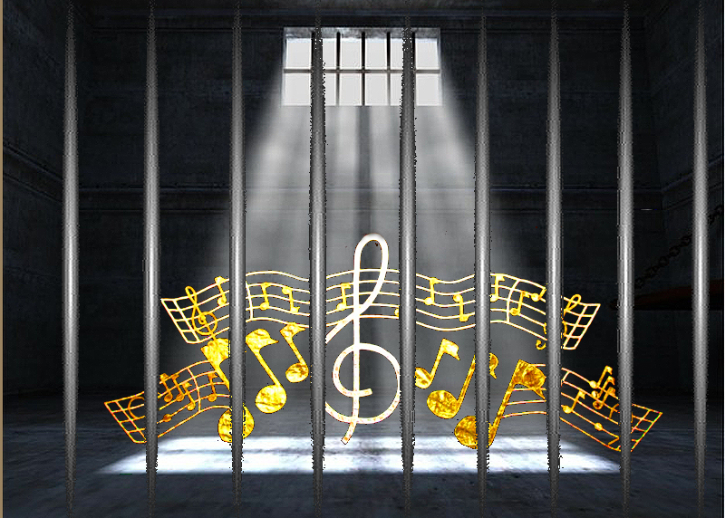
May the Lord grant us the grace to worship in His arms and to adore Him in spirit and truth, dear Heartdwellers. And Lord, I ask you to please cover this teaching with Your Blood, that the enemy cannot rob souls of this understanding, but that we will all flourish by doing what you teach us tonight.

As I was worshipping the Lord to some of Julie True’s music, the Lord pointed out several things to me. Namely, she uses very little lyrics and repeats them without embarrassment. I contrast that to myself, where I love to cram a song full of meaning with lyrics. Well—is that just my style—or am I missing something? Because very often I have to work hard to bring together 4 stanza’s of a song.

But my most interesting observation was a complete abandon to the song. Relaxing—yet not falling asleep as I usually do when I worship. Thank you, Coffee! I realized as I hummed and sang along with her lyrics that I was holding the Lord and singing them to Him. Oh Glory to God, I have always wanted that gift…worship from the heart, seeing Jesus and ministering to Him. Wow! That really brought something up in me.

Jesus began to explain, “You see, when you relax into the song…it takes you to a different place, Clare. You don’t always have to fall asleep. You can let go into that deep place of contemplation and prayer. This is the secret—not putting it out, but letting it go from deep within. This is a secret to this kind of singing. It comes so naturally, without strain. After a good warm up, you can fall back into rest, contemplating your head on My chest and let the music of your heart flow out unto Me. Where I, too, enter in to this deep place of the communion of hearts and everything you feel about Me can begin to escape from that prison cell where you keep it all locked up."

Lord, I wasn’t aware that I was keeping anything in a prison cell. Although I have felt that there's more and that it was tied up somewhere.

He continued, "Feelings. Deep, deep feelings. Without focused effort, you move much too fast to inhale My love and become inebriated in Me. This is a deep, hidden place within you where you keep things locked up—when I want them flowing out into this very needy world. It’s a matter of letting go, not capturing or producing. Or gutting it out. Do you see?"

Kind of.

"No effort. Effort ends somewhere in the midst of warmup. Then, as your focus shifts to Me, worship begins. And yes, the very small amount of words is significant. People read so much into one or two words or phrases. Wordy songs don’t take you to the same place; they don’t take others to the same place. Rather, they stimulate the intellect when I am trying to reach the soul. Emotion and the seat of emotions is where I can do My deepest work.

“Music communicates where words leave off. That is why it is such a powerful medium. It changes the entire atmosphere. Once more, angels are drawn around the source, as a moth to the flames of a campfire. You see, it is very dark here. But when you sing, even vocalizing from the heart, the flames leap up and illuminate the darkness, and the angels come to participate in worship.

"Oh, how I wish you could hear them! Truly it is something to behold. They are so very sensitive, Clare. The least little movement of worship enkindles in them the flames of devotion to Me. Their voices sing 'Amen, Amen, Amen' yet without forming the words, and a wonderful harmony is created. Oh, how wonderful and sublime…I rejoice and am greatly comforted by these events.

"There is a difference. The world tends to push lyrics out there, not realizing that the true door to a soul’s heart is not through the words as much as through the melody. Yes, the words are important. But as I said before, when you get wordy, you lose contact with the heart and are going back into the intellectual realm, which it is better to bypass.

"You remember the movie, The Mission and how the savages responded to the sweet melody? What a picture that was. That is the power of music to transform a soul.

"This is My gift to you, Clare. The melodies are very moving. You have a heart that stirs for melodies and you can stir others into a flame through them in skillful playing and very simple singing. Isn’t that just marvelous?"

Oh, indeed it is Lord! I have made it much too hard for myself.

He continued, "Yes, melody reaches into the heart and words call to the intellect. Not that they can’t be used together in a skillful way, but that is where simplicity comes in. I know you have not understood that before, but now I am opening this wisdom up to you. Draw My Bride into My arms with your music. There I will heal and restore her. Let go. Let go. Let go."

I glanced up at the clock and it was 2:22...

"Let Me ride on the current of your breath into their hearts where I apply the healing balm of My love and forgiveness.

"So few do not understand this supremely simple way of reaching souls, but this is the season for it, a spiritual renaissance drawing My Bride to a mountain of sweetness. So, don’t work so hard on the lyrics—that spoils it. You see, you have been side-tracking yourself by making clever lyrics rather than a simple few words I can enter their hearts with.

"It may shock you to know, but so many secular musicians are receiving songs from Heaven..."

When He said that, I was reminded of the song, "I'm Your Angel". That was Kelly and Celine Dion. It's a beautiful song, I put it in my worship list.

"Many secular musicians are receiving songs from Heaven, just because I am hungry to reach out to the lost and there are things hidden in these melodies that excite the spirit and actually draw them to the Kingdom and into My presence. They are seeking, and in these songs the vibrations that set in motion the feelings are being touched in ways that are beyond words.

"There are MANY songs from the 60’s that actually paved the way for a spiritual renewal, breaking the fallow ground and plowing deeply men’s needs to be released from the prison of conformity. Once they are out of that place, the devils contend with Me for their souls. But from this place of freedom they can hear Me much more clearly than they did under a cloud of condemnation and religious spirits.

"When a man or woman are truly set free from the pain, the scars, the fears— everything in their past that left them bound. When they are set free, that God-shaped place inside longs for Me. That’s when I come to them—when they are ready.

"As I have said many times before, men who are used to controlling, limiting, defining and defending all kinds of boundaries, cage the spirit and cause fear—which is what controls their choices. When they are free of that influence, they may seek the things of darkness but will tire of them and begin to seek the Light. But without that freedom, they stay locked into tightly defined cells, caged by so many fears that they can't have an intimate relationship with Me.

"When they are set free, burned by the illusions and disappointments of darkness, they begin seeking the Light and finding comfort there. Then they make the decision to live in My Light, where there is wisdom, love and nurturing. I want souls drawn to Me by love NOT fear. Fear may work initially to bring them into the Kingdom, but it will never bring them into My arms.

"Fear will cause them to keep their distance, while Love will cause them to surrender to Me and receive all I have to give them, in the secure knowledge that they are truly loved for who they are, right now, in present time. Not loved for their works, loved for their beauty. How can I fail to love the beautiful creatures I made them to be? I cannot. The love that formed them in My Father’s being, calls out and draws them back to that holy of holies, forever more united to Me in supreme bliss.

This is a great gift and we are doing it together. Go forth now with this new understanding and we will create through your sincere and gentle worship a great fishnet for souls."

